***Connecting to the All Saints’ services***

Click the link in the email, OR…

1. Open your internet browser (Edge, Chrome, Firefox, Safari, etc).
2. Type **eldersconference.org** in the address bar, then hit the ENTER key on your keyboard

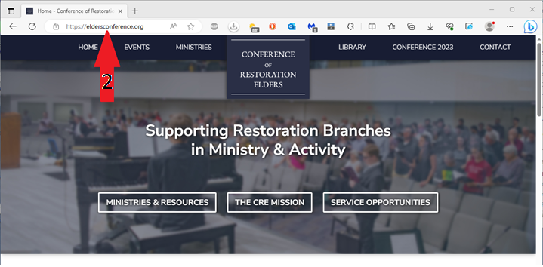

1. Click the MINISTRIES menu item

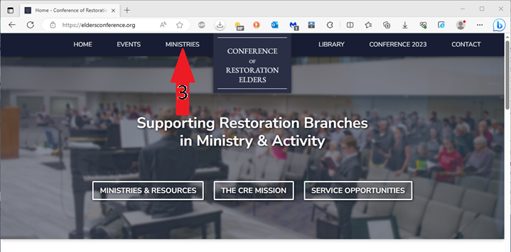

1. Scroll down to the **All Saints’ Zoom Group** option and click the title text

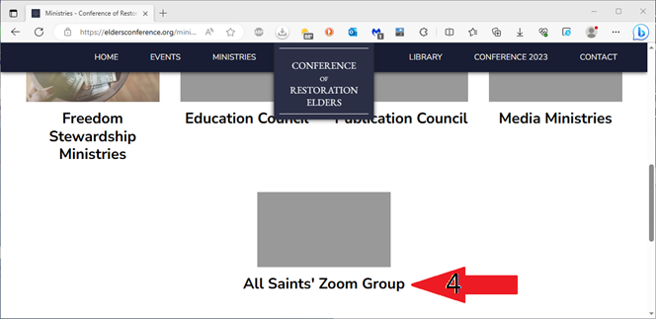

1. Click the link for the service you would like to attend (Sunday or Wednesday)

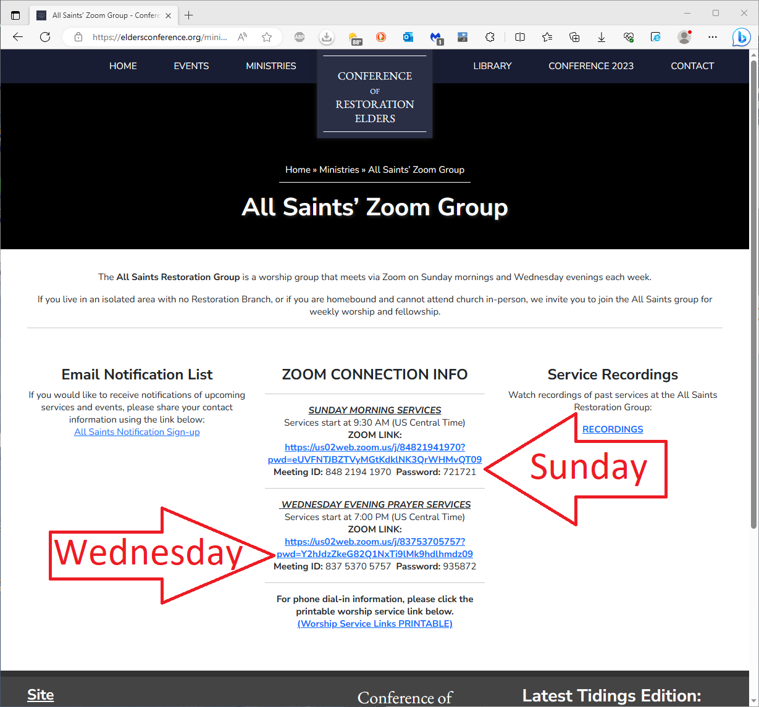

Access past services using the **Recordings** link on the right side of the page

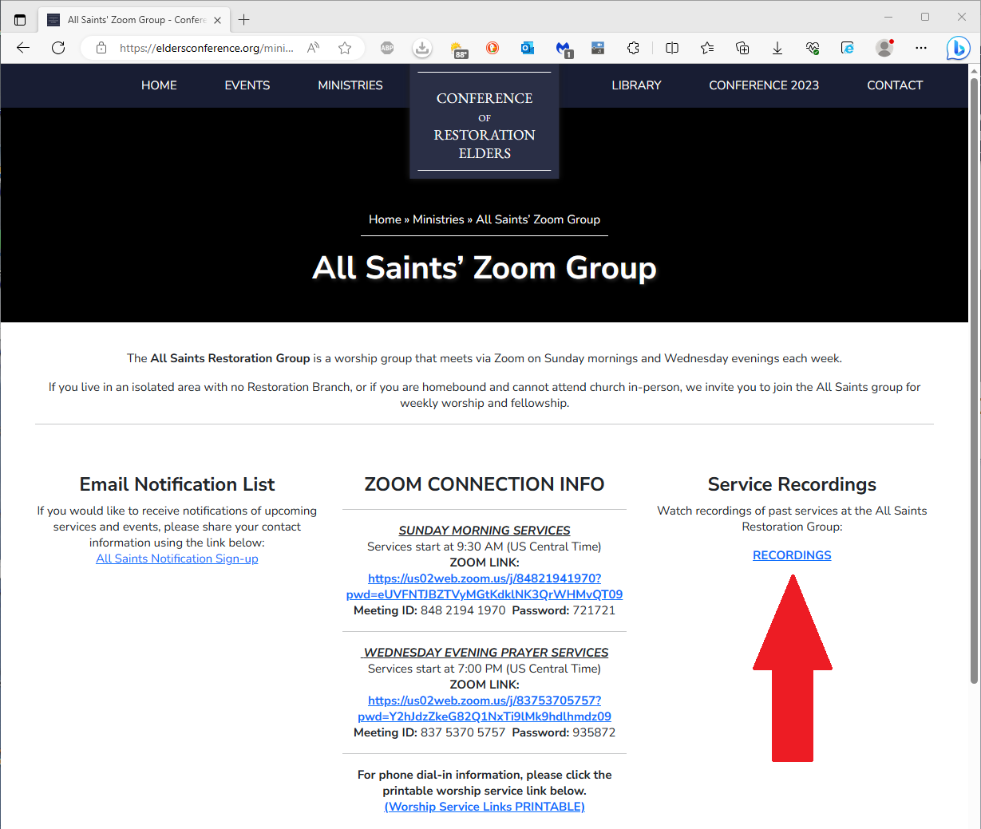

***Using Zoom on a mobile device***

|  |  |
| --- | --- |
| *Home Screen (Presenter’s View)*  Tap the screen to bring up options  ***Pro Tip:*** During the meeting, you can swipe left or right to change the view.  **Presenter’s view:** Shows the person who is currently speaking  **Gallery view:** Shows multiple participants | Options will appear along the bottom of the screen  *From left to right:*  **Mute/Unmute** toggle  **Video on/off** toggle  **Participants:** List of all participants  **Chat:** Open the chat feature to view/send chat messages to other participants  **Reactions:** Use to raise your hand or offer other reactions without speaking |

|  |  |
| --- | --- |
| *Chat Screen*  Tap **Close** in the upper left corner to exit the chat screen | *Reactions Options*  Tap the reaction emoji you would like to display for others to see. This includes the Raise Hand feature. |

*Discussion Points*

Basic computer components (What to consider when buying a computer)

*[Office worker analogy]*

CPU – Brain (does all the processing/”thinking”) *[Office Worker]*

RAM / Memory – Used when the computer is “thinking” *[Desk]*

Cache – Helps the computer to “think” faster *[Assistant]*

Hard Drive (HDD) – Storage capacity, how much information can be saved *[File Cabinet]*

 In general, higher numbers mean better and faster, but that also means more expensive.

1. How to tell the difference between an email address and a web address
   1. An Email address will always contain the @ symbol ([sean@telljohann.com](mailto:sean@telljohann.com))
   2. A web address will end in .com,.org,.net or something similar (limarestorationbranch.org)
2. Wifi / Hotspot / Ethernet / DSL / Cable Modem: What’s the difference?
3. What is bandwidth?
4. What is spoofing?
5. What is phishing?
6. What is malware, virus, ransomware etc.?
7. What is AI, deepfakes etc.?

***Glossary of Terms***

1. **Address bar or box** (noun) – the narrow, rectangular box on the topmost part of a browser window where you can type in a web address.
2. **Backup** (verb) – to copy files or databases to another site or an external drive (for example a USB flash drive or stick). This is done to preserve data in case of equipment failure or any other problems.
3. **Bookmark** (verb) – saving a webpage so you can easily go back to your favorite locations on the Web. On Google Chrome, you can bookmark by clicking on the star on the rightmost part of the address bar.
4. **Browse** (verb) – or surf, means to explore a website or a number of websites by scanning and reading information.
5. **Browser** (noun) – software used to find information on the Web. Examples are Google Chrome or Microsoft Internet Explorer.
6. **Cursor** (noun) – a small image on the screen that shows you where you are pointing. If you are typing, it is a blinking short line after the last character or space. Your cursor can also be seen as an arrow, pointing hand, or hourglass depending on what task you are doing.
7. **Desktop** (noun) –what is displayed on your screen after you turn the computer on. You can see your folders and program icons on your desktop.
8. **Dialog box** (noun) –a box that appears on your screen when the computer needs additional information to carry out a task. For example, when you open Skype, a dialog box appears and asks you your user name and password.
9. **Download** (verb) – to receive data from a web page.
10. **Flash drive or stick** (noun) –a computer hardware you plug in to your computer to save (and transfer) files.
11. **File** (noun) –an object in the computer that stores data, information, or commands used in a computer program. You create files using a software program.
12. **Folder** (noun) –a virtual location where your files, programs or other folders are located. These are easy to locate as the icon looks like a yellow office folder in most computers.
13. **Hardware** (noun) –are computer components that you can physically touch. Examples are your laptop, desktop computer, mouse, keyboard, and monitor.
14. **Homepage** (noun) – the opening page of a website. In most websites, you go back to this when you click on “Home” or the site’s logo.
15. **Icon** (noun) –a small image that you click on to open a file, start a command, or launch a program.
16. **Link or hyperlink** (noun and verb) –a highlighted or underlined feature on a web page that, when clicked, takes you to another web page. When you point to an underlined word or image, you will know that it is a link when your cursor turns into a pointing hand.
17. **Log-on or Sign-in** (verb) – to gain access to a computer system or a page on a website by entering a password or user ID.
18. **Menu** (noun) – a list of options or topics on a website that users can choose from.
19. **Password** (noun) – a secret set of characters or words used to gain access to a computer, web page, network, or file. You can use a combination of letters (upper case and lower case), numbers and other characters. A strong password should be hard to guess.
20. **Reboot** (noun) – to restart your computer.
21. **Scroll** (verb) – to move text or other information on a computer screen up, down, or sideways.
22. **Search** (verb) – using keywords or images to look for or retrieve data or webpages and other information on the [**World Wide Web**](http://www.webopedia.com/DidYouKnow/Internet/Web_vs_Internet.asp).
23. **Search engine** (noun) – programs that search documents for specified keywords and returns with a list of documents where the keywords are found. Commonly used search engines are Google, Bing and Yahoo!
24. **Site map** (noun) – a list of contents on a website, similar to an index in a book. A link to this is usually found on the homepage.
25. **Software** (noun) – software is a set of instructions for a computer to perform specific operations. Examples are your computer’s operating system, internet browser, Microsoft Office, or any computer program.
26. **Spam**(noun) – this is electronic junk mail or any unsolicited email. It usually contains advertising or product/service promotions.
27. **Taskbar** (noun) – this usually at the bottom of your desktop. This is where icons of programs you usually use may be found. You will also see the Start button here, as well as the date, time, status of your battery charge, volume, and other icons you wish to add. Apple Macintosh users may be more familiar with the term “dock”.
28. **Update** (noun) – a software file that contains fixes for problems found by users or the software developer. These are usually free and have small file sizes.
29. **Upload** (verb) – to save or send data to a network or another computer. You upload information when you post words, pictures or videos on social media, send an email, or save files on a website.
30. **Virus** (noun) – a program or a piece of code that is loaded onto your computer without your knowledge (via a document or a program). It can cause unexpected or damaging effects, such as corrupting the system software or destroying data.